FUTURISTIC BIOMETRIC SYSTEMS FOR AUTOMOBILES

¹Dr. S Umamaheswari P. Sri Hari R. Sudhin K.Venkatesh
Dept of Electronics and Dept of Electronics and Dept of Electronics and Dept of Electronics and
Communication Communication Communication Communication
Engineering, Kumaraguru Engineering, Kumaraguru Engineering, Kumaraguru Engineering, Kumaraguru
College of Technology, College of Technology, College of Technology, College of Technology,
Coimbatore. Coimbatore Coimbatore Coimbatore
umamaheswari.s.ece@kct.ac.in srihari.20ec@kct.ac.in sudhin.20ec@kct.ac.in venkatesh.20ec@kct.ac.in

Abstract
To create a sophisticated vehicle access authentication system by combining fingerprint and face recognition technologies while incorporating IoT connectivity for remote monitoring and control where users are able to give remote access to vehicle for authorized use. The methodology involves designing the system architecture, curating a diverse dataset for algorithm training, developing robust biometric algorithms, and integrating hardware components, such as the ESP32-CAM and Node mcu, to ensure seamless communication and IoT connectivity. Rigorous testing and validation are conducted to verify the system's accuracy and reliability. The result is a multi-layered security approach that enhances vehicle security by allowing only authorized users to access vehicles, thereby reducing the risk of theft and misuse. Users can conveniently manage access permissions and receive real-time alerts through the IoT connectivity. Stringent security measures are implemented to protect data and communication channels, adhering to privacy regulations. This system offers a secure and user-friendly solution that enhances vehicle security while providing a seamless and efficient experience for users.
Keywords: Internet of Things (IoT,)Machine Learning, Real-Time Embedded Systems
.
I. Introduction

In our fast-paced world, technology has become an integral part of our daily lives, significantly impacting various aspects, including transportation. The evolution of the transportation sector has seen remarkable innovations geared towards enhancing convenience and security for vehicle users. A notable advancement in this regard is the development of a robust Vehicle Access Authentication System [1]. This sophisticated system integrates biometric recognition, specifically fingerprint and face recognition, with Internet of Things (IoT) connectivity, marking a substantial leap forward. Its multifaceted approach not only addresses the critical need for heightened vehicle security but also promises a seamless and user-friendly experience.
As technology in vehicles advances, so does the ingenuity of those seeking unauthorized access. Car theft and unauthorized usage remain ongoing concerns for vehicle owners and manufacturers. While traditional methods like keys and key fobs have been effective to some extent, they are not fool-proof.

Furthermore, the rise of the Internet of Things (IoT) has opened up new possibilities in vehicle access control [4,7]. The ability to remotely monitor and manage vehicle access through IoT connectivity offers a range of benefits, from tracking vehicle location to authorizing temporary access for others. This enhances the control and convenience for vehicle owners.
This document thoroughly explores the design and development of an effective Vehicle Access Authentication System, addressing challenges and leveraging the power of biometric recognition and IoT technology. It provides a detailed analysis of the system's architecture, data collection, algorithm development, hardware integration, testing, and security measures. Ultimately, this document highlights how this innovative system has the potential to revolutionize vehicle security while enhancing the user experience, showcasing the capability of technology to strike a balance between security and user convenience in our modern world.
In the era of technology's increasing influence, the creation of an all-encompassing Vehicle Access Authentication System stands to redefine how we secure and manage access to our vehicles. This system represents a fusion of cutting-edge biometric recognition technologies—such as fingerprint and face recognition—and the capabilities of Internet of Things (IoT) connectivity, all aimed at achieving a harmonious balance between heightened security and user convenience.
At the heart of this system lies a meticulously designed architecture, integrating components like the ESP32-CAM for face recognition, Nodemcu with a fingerprint sensor, an IoT module, and a web application. These components collaborate seamlessly, establishing a secure and user-friendly ecosystem for vehicle access [3]. The foundation for accurate biometric recognition lies in a diverse dataset, essential for training fingerprint and face recognition algorithms. This diversity ensures the system can reliably identify authorized users under various conditions [8]. The system's efficacy relies on precision in crafting biometric recognition algorithms using appropriate libraries. This precision ensures accurate differentiation between authorized users and unauthorized individuals.
Hardware integration involves configuring microcontrollers, establishing communication protocols, and enabling IoT connections. The system's success depends on the efficient interplay between these hardware components, ensuring a smooth user experience. The seamless interaction between biometric recognition algorithms, the IoT module, and the web application is crucial for the system's optimal functioning. Rigorous testing procedures validate its accuracy, robustness, and efficiency under diverse conditions [11]. Additionally, security measures, including data encryption and privacy regulation compliance, are implemented to safeguard user information.

II. Literature work
Recent increases in vehicle thefts have underscored the critical importance of addressing vehicle security concerns. Another noteworthy issue revolves around the management of vehicle keys, which often necessitates carrying them and poses a significant problem when keys are misplaced or lost. In response to these challenges, we propose a solution in the form of a fingerprint vehicle starter system. This innovative system offers a secure and convenient method for starting and stopping the vehicle engine without the need for physical keys. Users simply need to scan their fingerprints, eliminating the requirement to carry traditional keys. The system grants authorized users the ability to initiate the vehicle, and users can easily enroll in the system by registering their fingerprints. The system accommodates multiple users, leveraging an Atmega 328 microcontroller and esp8266 Wi-Fi module [1].

The escalating frequency of vehicle thefts and the growing number of unlicensed drivers pose a significant challenge, necessitating a collective responsibility for both manufacturers and luxury car owners to incorporate effective antitheft systems. This thesis addresses this concern by designing a comprehensive security system for vehicles. The system comprises components such as Arduino, Driver's License (DL) card, Radio Frequency Identification reader (RFID), Fingerprint module (FP), and a Global System for Mobile Communication modem (GSM) [10, 9]. The Arduino serves as the central processing unit of the system, capable of adding authorized driver's licenses and fingerprints into its program. When an individual inserts their driver's license into the RFID reader, the system compares it with the stored data. If the license is authorized, the person is prompted to place their finger on the FP scanner for verification. If a match is confirmed, the ignition system is activated, allowing the person to drive the car. In the event of unauthorized access, a Short Message Service (SMS) is sent via the GSM modem to the vehicle owner, and the ignition system is blocked. Additionally, an SMS is dispatched to the driver's license holder, reminding them to renew their DL before expiration [10]. The (FFT) Fast Fourier Transform is used in the face recognition is done by implementing the concept of machine learning. The equation of (DFT) Discrete Fourier Transform is as follows,

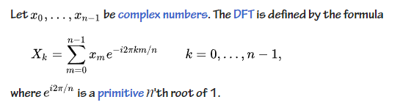

The conventional methods employed for vehicle protection are not only expensive but also complex, lacking subsequent actions or options for the car owner once their vehicle is stolen. The ubiquity of biometrics, particularly fingerprints, in various environments such as businesses, public buildings, and educational institutions, inspired the primary aim of this study—to implement a fingerprint recognition technology that is not only swift and straightforward but also transparent, dependable, and cost-effective for securing vehicles against unauthorized entry. The need for constant vehicle tracking and mileage monitoring prompted the integration of active vehicle monitoring and GPS technologies. In this system, the sensor captures fingerprint images, comparing them to a database or module within the system. The proposed GPS and GSM-based anti-theft car monitoring system emerges as a cost-effective solution for tracing a vehicle's location and has the added functionality of locating stolen vehicles [4].

III. Methodology

The methodology for implementing the proposed Vehicle Access Authentication System is a multi-faceted process that encompasses several key stages, each designed to ensure the system's reliability, effectiveness, and adherence to privacy and security standards. The methodology begins with the design of the system's architecture, which integrates various components, including the ESP32-CAM for face recognition, Nodemcu with a fingerprint sensor, an IoT module, and a user-friendly web application. This architecture forms the backbone of the system, enabling the seamless interaction and communication between its different elements.
Data collection and preparation represent a critical step in the process, involving the curation of a diverse dataset to train the fingerprint and face recognition algorithms. The quality and diversity of this dataset are essential to ensure that the biometric recognition algorithms can reliably identify authorized users in various real-world scenarios. The image obtained from the node mcu is broken down frame by frame and the module is trained with the authenticated fingerprint and face recognition.

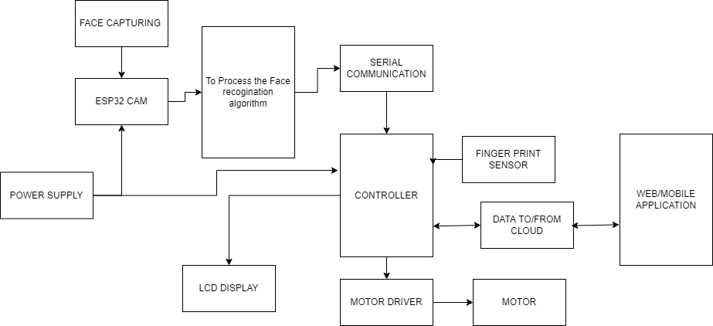

Figure 1: Schematic outline of proposed system

Algorithm development follows, wherein the fingerprint and face recognition algorithms are meticulously crafted using suitable libraries. The goal is to achieve a high level of accuracy in distinguishing authorized users from unauthorized individuals, reducing the risk of false positives and false negatives during the authentication process. Hardware integration involves configuring microcontrollers, establishing communication protocols, and enabling IoT connectivity. This step ensures that the system's hardware components work cohesively, enabling smooth and secure interactions between the biometric recognition methods, IoT module, and web application.

Implementation of stringent security measures is crucial to safeguard data and communication channels, ensuring that user information remains confidential and in compliance with privacy regulations. Measures such as data encryption, secure communication protocols, and privacy controls are put in place to protect sensitive user data.
This methodology is designed to guide the development and implementation of the Vehicle Access Authentication System, emphasizing a comprehensive and rigorous approach to create a highly secure, reliable, and user-friendly solution that addresses the challenges of modern vehicle security and access management.

IV. Descriptions of Hardware used

- NODEMCU

The Atmel AVR® core helps inintegrating instruction set with the help of 32 working registers which are general-purpose registers.All 32 registers are directly connected along with Arithmetic Logic Unit (ALU), which allow accessing for within a single clock cycle. The ATmega328/P features includes, 32 Kilobytes of In-System Programmable Flash with Read-While-Write capabilities, 1Kbytes of EEPROM, 2 Kilobytes of Static Random Access Memory (SRAM, 1 serial programmable USART, a 1-byte-oriented 2-wire Serial Interface (I2C), a 6-channel 10-bit ADC (8 channels in TQFP and QFN/MLF packages), a programmable Watchdog Timer with an internal Oscillator, an SPI serial port, and six software-selectable power-saving modes.

This configuration ensures a swift start-up with minimal power consumption. In Extended Standby mode, both the main oscillator and the asynchronous timer remain active..
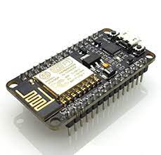
Figure 2a: NODEMCU (ESP8266)

Atmel offers the QTouch® library to integrate the functionality of capacitive touch buttons, sliders, and wheels into AVR microcontrollers. The patented charge-transfer signal acquisition guarantees reliable sensing and incorporates fully debounced reporting of touch keys. It also includes Adjacent Key Suppression® (AKS™) technology to ensure clear detection of key events. The user-friendly Q Touch Suite toolchain simplifies the exploration, development, and debugging of personalized touch applications.

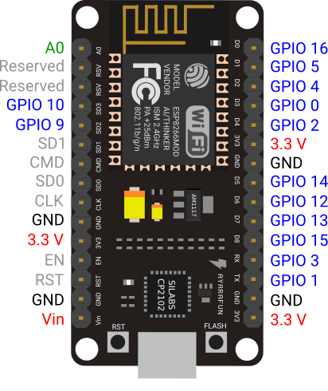
Figure 2b: Pin structure of ATMEGA328.

• AVR Microcontroller with 28 pins
• Program Memory in Flash: 32 kilobytes
• Data Memory in EEPROM: 1 kilobyte
• Data Memory in SRAM: 2 kilobytes
• Total I/O Pins: 23
• Timers: Two 8-bit and One 16-bit
• Analog-to-Digital Converter (A/D Converter): 10-bit, Six Channels
• Pulse Width Modulation (PWM): Six Channels
• Real-Time Clock (RTC): Included with a Separate Oscillator
• Master and Slave Support for SPI and I²C in MSSP
• USART: Available
• External Oscillator: Capable of running up to 20MHz

Features and specifications of the ATMEGA328 are listed above.

- Rectifier Circuit

In rectifier circuits, the objective is to convert a sinusoidal AC voltage into its corresponding pulsating DC. However, this pulsating DC voltage contains undesirable AC components, including supply frequency and its harmonics, collectively known as ripples. Single-phase half-wave rectifiers exhibit the highest ripple, decreasing in single-phase full-wave rectifiers, and reaching a minimum in 3-phase rectifiers. Such supply is impractical for driving complex electronic circuits, necessitating a smoother and steadier DC output.
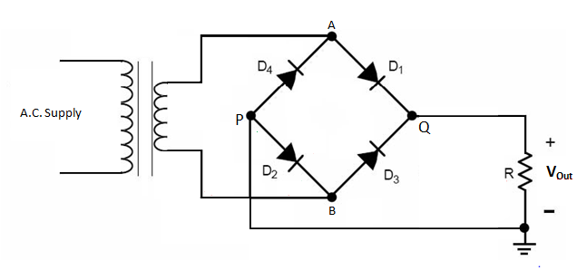
Figure 3: Rectifier schematic

For most applications, a constant DC voltage is preferable over the pulsating output of the rectifier, as the latter can compromise circuit performance. To achieve this, the rectifier output undergoes filtration through a filter circuit, comprising components like capacitors, resistors, and inductors. An inductor is employed due to its property of allowing only DC components to pass while blocking AC signals. Capacitors, on the other hand, block DC and permit AC to pass.

For a full-wave rectifier with a series inductor filter, the choke resistance (Ri) and load resistance (RL) form a voltage divider circuit, resulting in a DC voltage across the load

Vdc = Rl / (Ri + Rl)… (1)

Where Vdc is Direct Current Voltage, Rl is Load Resistance and Ri is Resistance due to current.

The shunt capacitor impedance (Zc) is inversely proportional to the frequency and capacitance

Zc = 1 / 2fC … (2)

allowing only DC components and few residual ripple components to pass through the load resistance (RLoad). This filter configuration is effective in bypassing high amounts of ripple components.

- ESP32-CAM

Powered by Espressif Systems' ESP32 microcontroller, the ESP32-CAM boasts dual-core processing, Wi-Fi, and Bluetooth connectivity, substantial memory, and a diverse array of I/O pins, providing project developers with flexibility. This amalgamation of features allows it to function both as a controller and a communication hub for diverse applications. A notable feature of the ESP32-CAM is its integrated OV2640 camera module, capable of capturing high-quality still images and videos. With a 2-megapixel resolution and support for various image formats, it caters to a broad spectrum of projects, ranging from surveillance cameras to image recognition applications. The ESP32-CAM's compact form factor enhances its versatility, featuring a standard OV2640 camera lens interface that facilitates upgrades or modifications to suit specific project requirements. Its pinout and mounting holes further contribute to its adaptability, allowing for seamless integration into custom enclosures or PCB designs.

In summary, the ESP32-CAM is a highly capable and adaptable microcontroller module, offering a comprehensive feature set suitable for a wide range of applications. Its integration of Wi-Fi, Bluetooth, and camera capabilities, combined with ease of programming and a robust developer community, positions it as a top choice for IoT, image capture, and communication projects. Its versatility, compact design, and compatibility with widely used development tools make it a powerful solution for both hobbyists and professionals in the embedded systems and IoT domains.
iv) Relay Module:

- Features of 5-Pin 5V Relay
- Trigger Voltage (Voltage across coil) : 5V DC
- Trigger Current (Nominal current) : 70mA
- Maximum AC load current: 10A @ 250/125V AC
- Maximum DC load current: 10A @ 30/28V DC
- Compact 5-pin configuration with plastic moulding
- Operating time: 10msec Release time: 5msec
- Maximum switching: 300 operating/minute (mechanically)

A relay acts as an electro-mechanical device that operates as a switch. It is triggered by applying DC power to the relay coil, causing contact switches to either open or close. Commonly, a 5V relay module, designed with a single channel, includes a coil and two contacts identified as normally open (NO) and normally closed (NC). Specifically designed for compatibility with a range of microcontrollers like PIC and Arduino, this module is utilized for managing high-voltage and current loads such as solenoid valves, motors, AC loads, and lamps..

v) LIQUID CRYSTAL DISPLAY (LCD)

Below is the table to illustrate the pin descriptions of LCD.

Pin No. | Symbol | Function
1 | Vss | Ground Terminal pin
2 | Vdd | Supply terminal +5v
3 | Vo | Voltage Power supply (LCD)
4 | RS | Register select  RS=0…Instruction register  RS=1…Data register
5 | R/W | Read/Write operation  (R/W) -- Read operation  (R/W) -- Write operation
6 | EN | Enable pin
7-14 | DB0-DB7 | Data Bus(Bi-directional). Data Transfer through DB0-DB7 set of pins for interfacing data length (8-bits); and two times, through DB4-DB7 in the case of interface data length is 4-bits.
15 | LAMP-(L-) | LED power supply pin
16 | LAMP+(L+) (E2) | Enable LAMP or LED supply

Table 1: Pin Descriptions of LCD

V. Experiment results and discussion

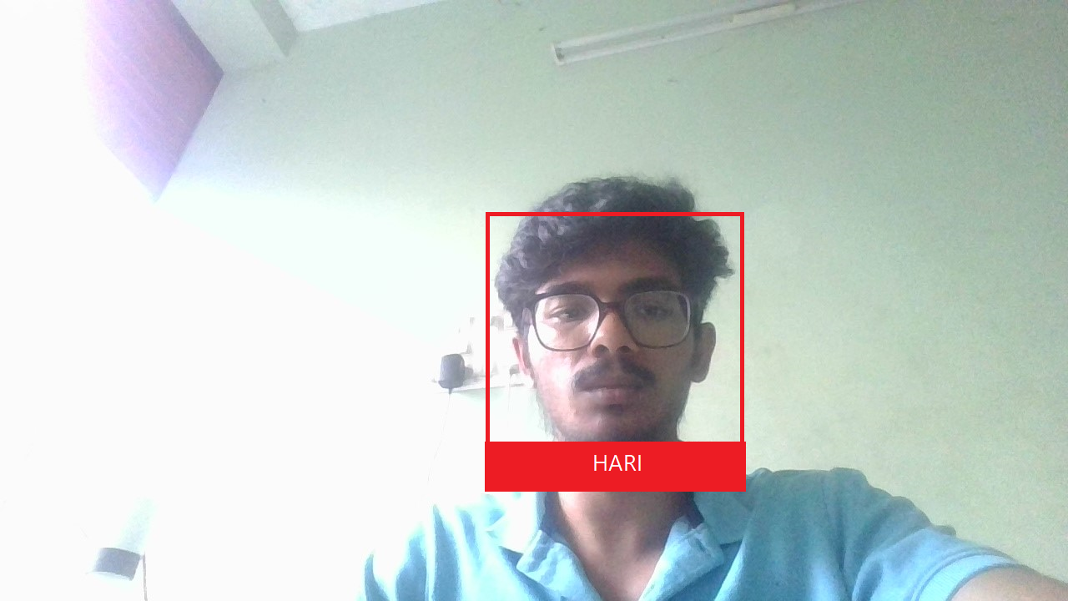
Figure 4a: Authorized user Face recognition

The figure shown below is the result of the algorithm involvd in the Authorized user identification. The ESP32- CAM takes the picture of the person trying to gain access processes it to 1’s and 0’s and the face is then recognized. Only when both the fingerprint and face of the user matches, the person can gain access to the automobile. If either of the finferprint or face matches, the user is denied access. But a user can alternatively gain access to the system through the notification sent throug the cloud.

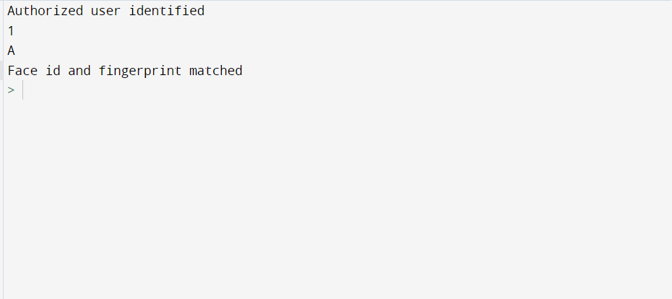

Figure 4b: Back end Python IDE for authorized user -identification

Font Size | Appearance (in Time New Roman or Times)
Font Size | Regular | Bold | Italic
8 | table caption (in Small Caps),  figure caption,  reference item |  | reference item (partial)
9 | author email address (in Courier),  cell in a table | abstract body | abstract heading (also in Bold)
10 | level-1 heading (in Small Caps),  paragraph |  | level-2 heading,  level-3 heading,  author affiliation
11 | author name
24 | title

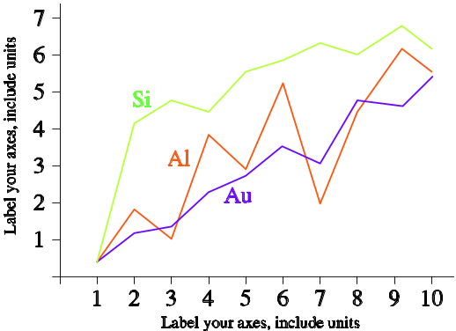
Fig.5 Silicon, Aluminium and Gold reactance graph

References

- L.Wang, & H.Xiao, "Biometric car security and monitoring system using IOT",2019 International Conference on Vision Towards Emerging Trends in Communication and Networking (ViTECoN)

- Shuai LV,Lele Wu,Zeyu Li,Qi Xu,Xinxin Zhou,"Intelligent Car Security System Based on Fingerprint Identification and Internet of Things",2021 13th International Conference on Computational Intelligence and Communication Networks (CICN)

- Marey Jemima Raj,Sajitha Gadde,Ramesh Jayaraman,"Implementation of Biometric Access Control Using Fingerprint for Safety and Security System of Electric Vehicle",2021 2nd International Conference on Smart Electronics and Communication (ICOSEC)

- K. Jeevitha,J. Venkatesh,V. Indhumathi,K. Krishna Veni,R. Prem Kumar,Devadarshini. M,"A Biometric Vehicle Theft Identification and Prevention Scheme using GPS Location Tracking",2023 International Conference on Advances in Computing Communication and Applied Informatics (ACCAI)

- Mridhula Ramesh,S Akruthi,K Nandhini,S Meena,S Joseph Gladwin,R Rajavel,"Implementation of Vehicle Security System using GPSGSM and Biometric",2019 Women Institute of Technology Conference on Electrical and Computer Engineering (WITCON ECE)

- Ahmed Sherif,Mohamed Elsersy,Mahmoud Nabil,Mohamed Mahmoud,Khaled H. Almotairi,"Privacy-Preserving Biometric-based Authentication Scheme for Electric Vehicles Charging System",2021 3rd IEEE Middle East and North Africa COMMunications Conference (MENACOMM)

- "Prototype of a fingerprint based licensing system for driving",2013 International Conference on Information Communication and Embedded Systems (ICICES)

- Zhaoxia Zhu,Fulong Chen,"Fingerprint recognition-based access controlling system for automobiles",2011 4th International Congress on Image and Signal Processing

- Mrinmoy Dey,Md. Akteruzzaman Arif,Md. Asif Mahmud,"Anti-theft protection of vehicle by GSM & GPS with fingerprint verification",2017 International Conference on Electrical Computer and Communication Engineering (ECCE)

- Arwa M. Ali,Heisum M. Awad,Ibrahim K. Abdalgader,"Authenticated Access Control for Vehicle

- Ignition System by Driveru2019s License and Fingerprint Technology",2020 International Conference on Computer Control Electrical and Electronics Engineering (ICCCEEE)

- Kgaotsang Thamoethata,Bassey Isong,Nosipho Dladlu,Adnan M. Abu-Mahfouz,"Analysis of IoT-based Vehicle Anti-Theft Security",2021 3rd International Multidisciplinary Information Technology and Engineering Conference (IMITEC)

- Kirtika A P S Parameswaran,Mazlina Abdul Majid,Md. Shohidul Islam,"Fingerprint Authentication-based Traffic Offence Control and Enforcement System on Smart Mobile Devices for Smart City",2022 International Conference on Intelligent Technology System and Service for Internet of Everything (ITSS-IoE)

- Mahesh R. Pawar,Imdad Rizvi,"IoT Based Embedded System for Vehicle Security and Driver Surveillance",2018 Second International Conference on Inventive Communication and Computational Technologies (ICICCT)

- Nikhil Gala,Anshu Poswalia,Riya Gharat,"Electric Bike Security: Biometric & GPS Integration for Intrusion Detection",2023 International Conference on Sustainable Computing and Data Communication Systems (ICSCDS)

- S Umamaheswari; M V Rahul Babu; D Dharun Prasanth; H Nandha Bharathi; M Alagumeenaakshi, “Smart Medical Dispenser With Pulse Meter” 2021 International Conference on Advancements in Electrical, Electronics, Communication, Computing and Automation (ICAECA), 18 January 2022.

- S. Umamaheswari; K.Hari Priya; D. Allinjoe, “ Towards Building Robust Song and Location Detection System Using LBP Features” 2021 International Conference on Advancements in Electrical, Electronics, Communication, Computing and Automation (ICAECA), 18 January 2022.

- Dharanikrishna B.V,Kavinprabhu. C,Harish S.Umamaheswari , “ Towards building of a robust organic tester” 2022 8th International conference on Advanced computing and Communication systems(ICACCS), 7 June 2022.

- SriSuvetha C.S,Saravanamani C.S,Subiksha S, Umamaheswari.S , “ Automatic Bio waste segregator” 2022 8th International conference on Advanced computing and Communication systems(ICACCS), 7 June 2022

